Al-Tarqi SkyCast Weather Web Application
Software Construction Project Report
Sohar University
College of Computing and Information Technology
Course: Software Construction
Course Code: COMP3131
Student Name: [Student Name]
Student ID: [Student ID]
Instructor: [Instructor Name]
Academic Semester: [Semester]
Submission Date: [Submission Date]
Prepared from the implemented React, TypeScript, Node.js and Express project in the shared workspace.

Abstract
This report documents Al-Tarqi SkyCast, a responsive weather web application presented through the SkyCast interface. The system addresses the practical need for a concise, location-aware weather overview and a simple path from city search to an outdoor decision. The implemented application opens without authentication, obtains current and forecast data from Open-Meteo, supports Arabic and English place search, resolves browser coordinates through reverse geocoding, displays current and hourly conditions, stores favourite places in browser localStorage, renders an interactive Leaflet map, and provides a weather assistant through a server-side Mibyan AI adapter. The server protects provider credentials and exposes application-specific routes to the React client.
The project uses React, TypeScript, Vite, Node.js, Express, Leaflet, OpenStreetMap tiles, Lucide icons and CSS. The assistant uses Mibyan’s OpenAI-compatible Chat Completions contract with a weather-aware prompt and a deterministic fallback when the provider is unavailable or the project key is unauthorised. This distinction is important: the integration is implemented, but the current workspace key was rejected during live verification, so the report does not claim successful model output.
The report separates verified implementation facts from future proposals. It covers requirements, architecture, UML-style diagrams, customer journey, UX, implementation, testing, quality, security, limitations and future work. It demonstrates Software Construction through clear API boundaries, environment configuration, reusable UI functions, error handling and iterative verification.

Table of Contents
Section | Page
Abstract | 2
1 Introduction | 3
2 Problem Analysis | 3
3 Objectives and Scope | 4
4 Stakeholder Analysis | 4
5 Requirements Analysis | 4–5
6 Development Methodology | 5–6
7 System Architecture | 6–7
8 Use Case Analysis | 7–8
9 Customer Journey and User Flow | 8–9
10 UML and Structural Diagrams | 9–10
11 User Interface and UX Design | 11–12
12 Database Design | 13
13 Technology Stack | 13
14 Software Implementation | 13–14
15 Software Construction Fundamentals | 14
16 Testing Strategy | 15
17 Software Quality Evaluation | 15
18 Security and Privacy | 16
19 Challenges and Limitations | 16
20 Future Improvements | 16
21 Conclusion | 16
22 References | 17
Appendices | 17–18

1 Introduction

1.1 Background
Al-Tarqi SkyCast is a browser-based weather dashboard whose visible product identity is SkyCast Weather. It was constructed as an interactive utility rather than a static HTML mock-up. The visitor enters directly, chooses a place, reads the current and near-term weather, saves useful places and asks the assistant for an interpretation.

1.2 Problem Statement
Weather information is often fragmented between a current-temperature screen, a forecast view, a search form and a map. The project addresses this fragmentation by placing the most relevant information in one visual dashboard. The problem is framed as an engineering requirement: a visitor needs a fast, readable and location-aware way to interpret current weather and plan an activity.

1.3 Aim and Objectives
The aim is to construct a responsive weather tool that gives visitors a reliable current view, supports place exploration and explains the available data in natural language when the AI provider is available.
- Open directly without registration.
- Search places in Arabic and English with country and region disambiguation.
- Use browser location only after an explicit user action.
- Display current temperature, apparent temperature, humidity, high/low, sunrise/sunset and hourly data.
- Persist favourite places and theme preference locally.
- Display an interactive map and selected-place marker.
- Connect the weather assistant through a server-side Mibyan adapter.
- Keep the hourly strip scrollable inside the page on phone widths.

1.4 Scope and Report Structure
The implemented scope is a single-page dashboard and Express API. It excludes accounts, database records, payments, push notifications, administrative screens and production deployment. Later sections document the actual code and distinguish future work from delivered behaviour.

2 Problem Analysis
The primary user is an anonymous visitor who wants an immediate answer. The interface therefore privileges a current card, a compact hourly timeline and activity suggestions. Search results include region and country because city names are not necessarily unique. Favourites are deliberately device-local because no identity or database layer exists.
Need | Implemented response | Boundary
Immediate orientation | Current card and selected city | No personal profile
Place discovery | Arabic/English geocoding | Provider quality varies
Comparison | Saved rows with temperatures | No advanced analytics
Interpretation | Activity cards and chat | Informational only
Spatial context | Leaflet map marker | No weather raster layers

3 Objectives and Scope
ID | Objective | Success criterion | Status
OBJ-01 | Fast access | Root dashboard opens without login | Implemented
OBJ-02 | Current weather | Values populated from /api/weather | Implemented
OBJ-03 | Global search | Arabic/English results include region | Implemented
OBJ-04 | Saved places | localStorage survives refresh | Implemented
OBJ-05 | Map context | Marker updates after selection | Implemented
OBJ-06 | Assistant | Valid Mibyan key returns completion | Partially verified
OBJ-07 | Accounts and alerts | Future backend scope | Future

“Partially verified” means the adapter and request path exist, but live Mibyan output was not confirmed because the current project key was rejected. This is not reported as a successful AI result.

4 Stakeholder Analysis
Stakeholder | Needs | Impact
Website visitor | Fast weather, search, readable UI, no account | High
Student developer | Maintainable code and provider configuration | High
Course instructor | Evidence of construction, testing and limitations | Medium
External providers | Valid requests and credential protection | Medium
Future maintainer | Documented endpoints and modular boundaries | Medium

No administrator, merchant or service-provider workflow was found in the inspected source, so these roles are not claimed as implemented stakeholders.

5 Requirements Analysis

5.1 Functional Requirements
ID | Requirement | Actor | Expected outcome | Status | Verification
FR-01 | Display selected-place weather summary | Visitor | Current card and metrics render | Implemented | UI/API test
FR-02 | Search a place in Arabic or English | Visitor | Disambiguated results appear | Implemented | Integration test
FR-03 | Select result and reload weather | Visitor | Cards and map update | Implemented | System test
FR-04 | Request device location | Visitor | Reverse-geocoded area is shown | Implemented; permission-dependent | Browser test
FR-05 | Browse 24-hour strip internally | Visitor | Page does not scroll horizontally | Implemented | Responsive test
FR-06 | Add/remove saved places | Visitor | localStorage list updates | Implemented | Functional test
FR-07 | Toggle units and theme | Visitor | Visible state changes | Partially implemented | UI test
FR-08 | Show map marker | Visitor | Marker follows place | Implemented | Integration test
FR-09 | Ask assistant question | Visitor | Model or fallback answer appears | Partially verified | API test
FR-10 | Handle provider failure safely | System | Fallback without key exposure | Implemented | Failure test

5.2 Non-Functional Requirements
Attribute | Interpretation | Evidence/status
Usability | Understand dashboard without registration | Mobile/browser review; verified for tested view
Performance | Keep client work and provider routes concise | No benchmark; not fully tested
Reliability | Maintain useful chat when provider fails | Fallback observed
Maintainability | Separate client, server, types and styles | Verified by source inspection
Compatibility | Work at desktop and phone widths | Phone viewport checked
Security | Keep keys server-side | Mibyan key read by Express only
Accessibility | Readable contrast and labelled controls | Partial; full audit not executed

5.3 Traceability Matrix
Requirement | Component | Test case | Status
FR-01 | App.tsx current card | TC-01 | Verified
FR-02 | /api/search + ask bar | TC-02 | Verified
FR-04 | useLocation + reverse-geocode | TC-03 | Permission-dependent
FR-05 | hour-columns CSS | TC-04 | Verified
FR-06 | favorites/localStorage | TC-05 | Verified
FR-08 | WeatherMap | TC-06 | Implemented
FR-09 | /api/chat + Mibyan | TC-07 | External key failed
FR-10 | Server fallback | TC-08 | Verified

6 Development Methodology
No formal Scrum board, sprint record or signed lifecycle document was found. It would therefore be inaccurate to claim a formal Agile, Scrum or Waterfall process. The available evidence shows an iterative construction loop: visual feedback was converted into requirements, bounded code changes were made, builds and browser checks were executed, and external-provider failures were diagnosed.
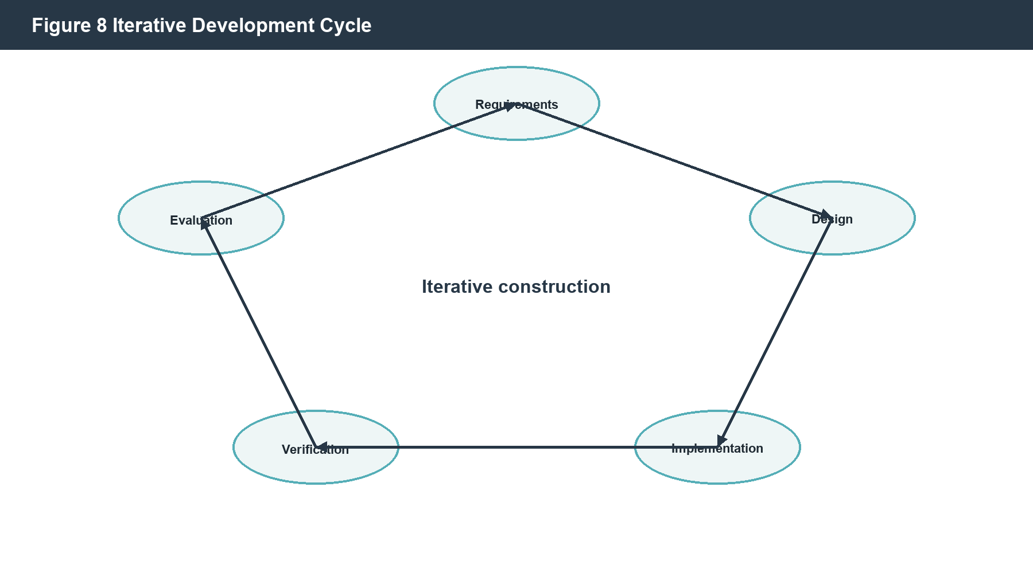
Figure 8: Iterative construction cycle inferred from the project work

7 System Architecture
The browser contains the React presentation layer and calls local Express routes. Express calls Open-Meteo for weather and geocoding, Nominatim for reverse geocoding, and Mibyan for chat. Leaflet loads OpenStreetMap tiles from the browser. Provider keys remain on the server.
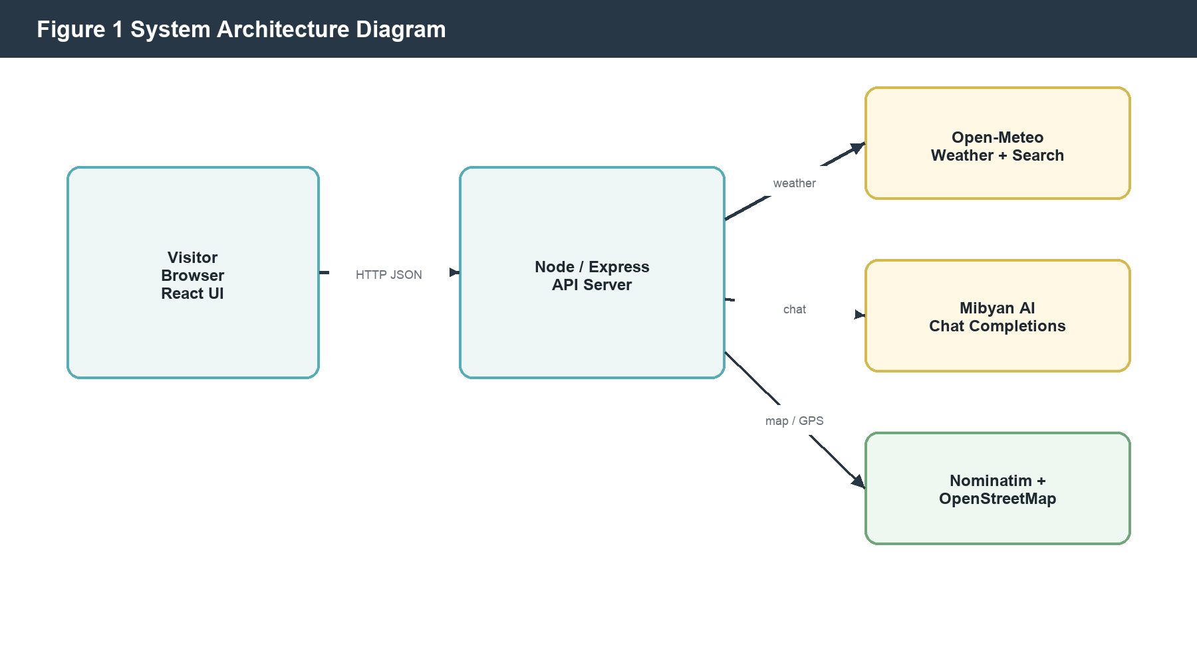
Figure 1: System architecture and external service boundaries
Component | Responsibility | Evidence
React/Vite client | UI, state, interactions | src/App.tsx and styles.css
Express server | Provider boundary and validation | server/index.ts
localStorage | Anonymous place/theme persistence | skycast:* keys
Open-Meteo | Forecast and geocoding | /api/weather and /api/search
Nominatim | Coordinate-to-area name | /api/reverse-geocode
Mibyan AI | Weather chat completion | /api/chat and MIBYAN_*
Leaflet/OpenStreetMap | Map and tiles | WeatherMap

8 Use Case Analysis
The primary actor is Visitor. The visitor is anonymous; there is no implemented account or administrator actor.
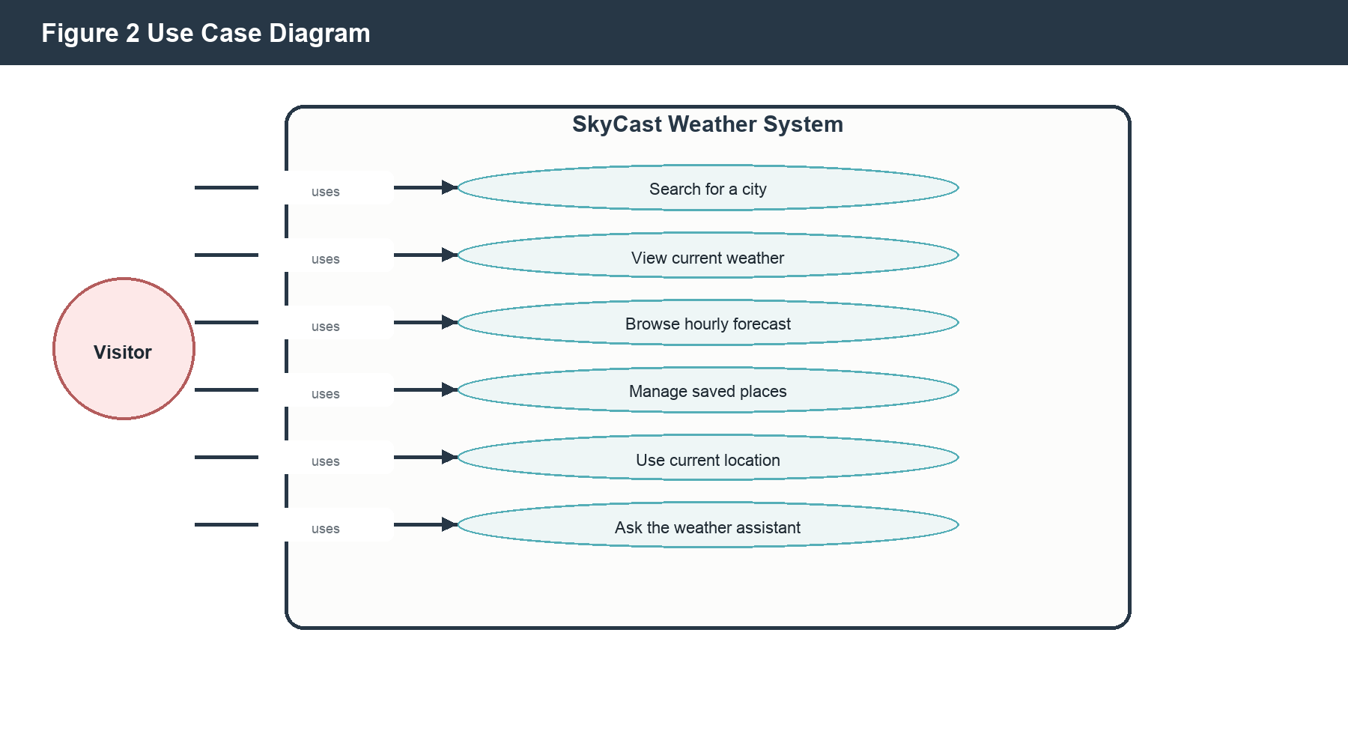
Figure 2: Use case diagram for the Al-Tarqi SkyCast website

UC-01 Search for a place
The visitor enters Arabic or English text; the client debounces it; Express queries both language variants; results are deduplicated by coordinates; the visitor selects a result. Empty results and provider failure are handled without crashing the page.

UC-02 View current weather
After a place is selected, the client loads current, hourly and daily payloads and renders the cards. Provider failure resolves loading without inventing values.

UC-03 Use current location
The visitor presses the location action, grants permission, and receives reverse-geocoded coordinates. Permission denial or reverse-geocoding failure produces a safe generic label.

UC-04 Ask the assistant
The visitor submits a question. The server sends location and weather context to Mibyan. If the provider key is missing or rejected, a bounded weather-data fallback is returned.

UC-05 Manage saved places
The visitor adds a search result or removes a saved row. React state and localStorage are updated, with duplicate place IDs ignored.

9 Customer Journey and User Flow
No field research or analytics dataset was supplied. The following journey is therefore proposed and illustrative, not a measured customer study.
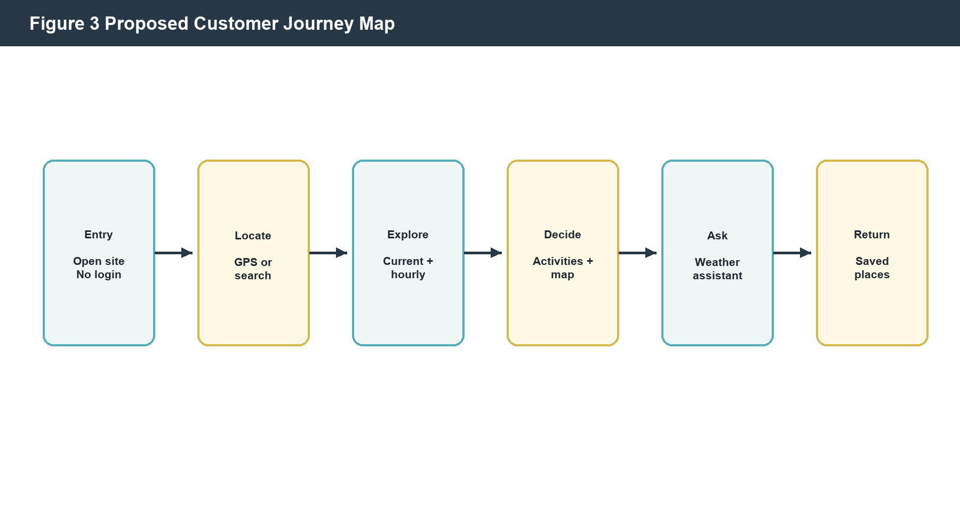
Figure 3: Proposed customer journey map
Stage | Action | Goal | Touchpoint | Pain point | Opportunity
Entry | Open site | Get weather now | Root dashboard | Location may be unclear | Show selected city clearly
Locate | Use GPS/search | Find relevant place | Location/search control | Similar names | Show country/region
Explore | Read cards | Understand now/next hours | Current and hourly cards | Information density | Preserve hierarchy
Decide | Review activities/map | Plan activity | Activity icons/map | Suggestions are informational | Label clearly
Ask | Send question | Interpret data | Chat popup | External provider limits | Show provider/fallback status
Return | Open saved place | Compare quickly | localStorage rows | Device-specific data | Optional account sync later

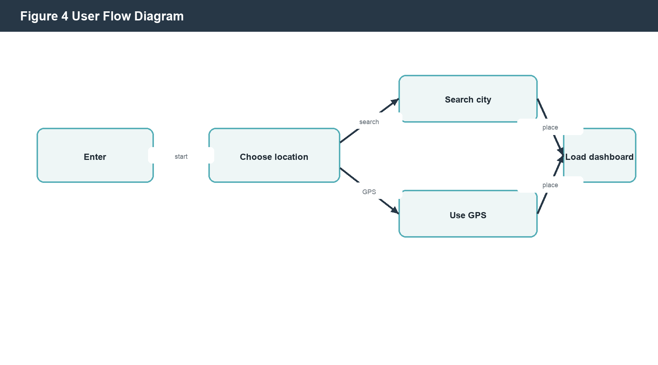
Figure 4: User flow from entry to selected weather dashboard

10 UML and Structural Diagrams

10.1 Activity Diagram
The activity model shows how current weather can inform a simple activity suggestion. It is informational and is not a safety or medical decision engine.
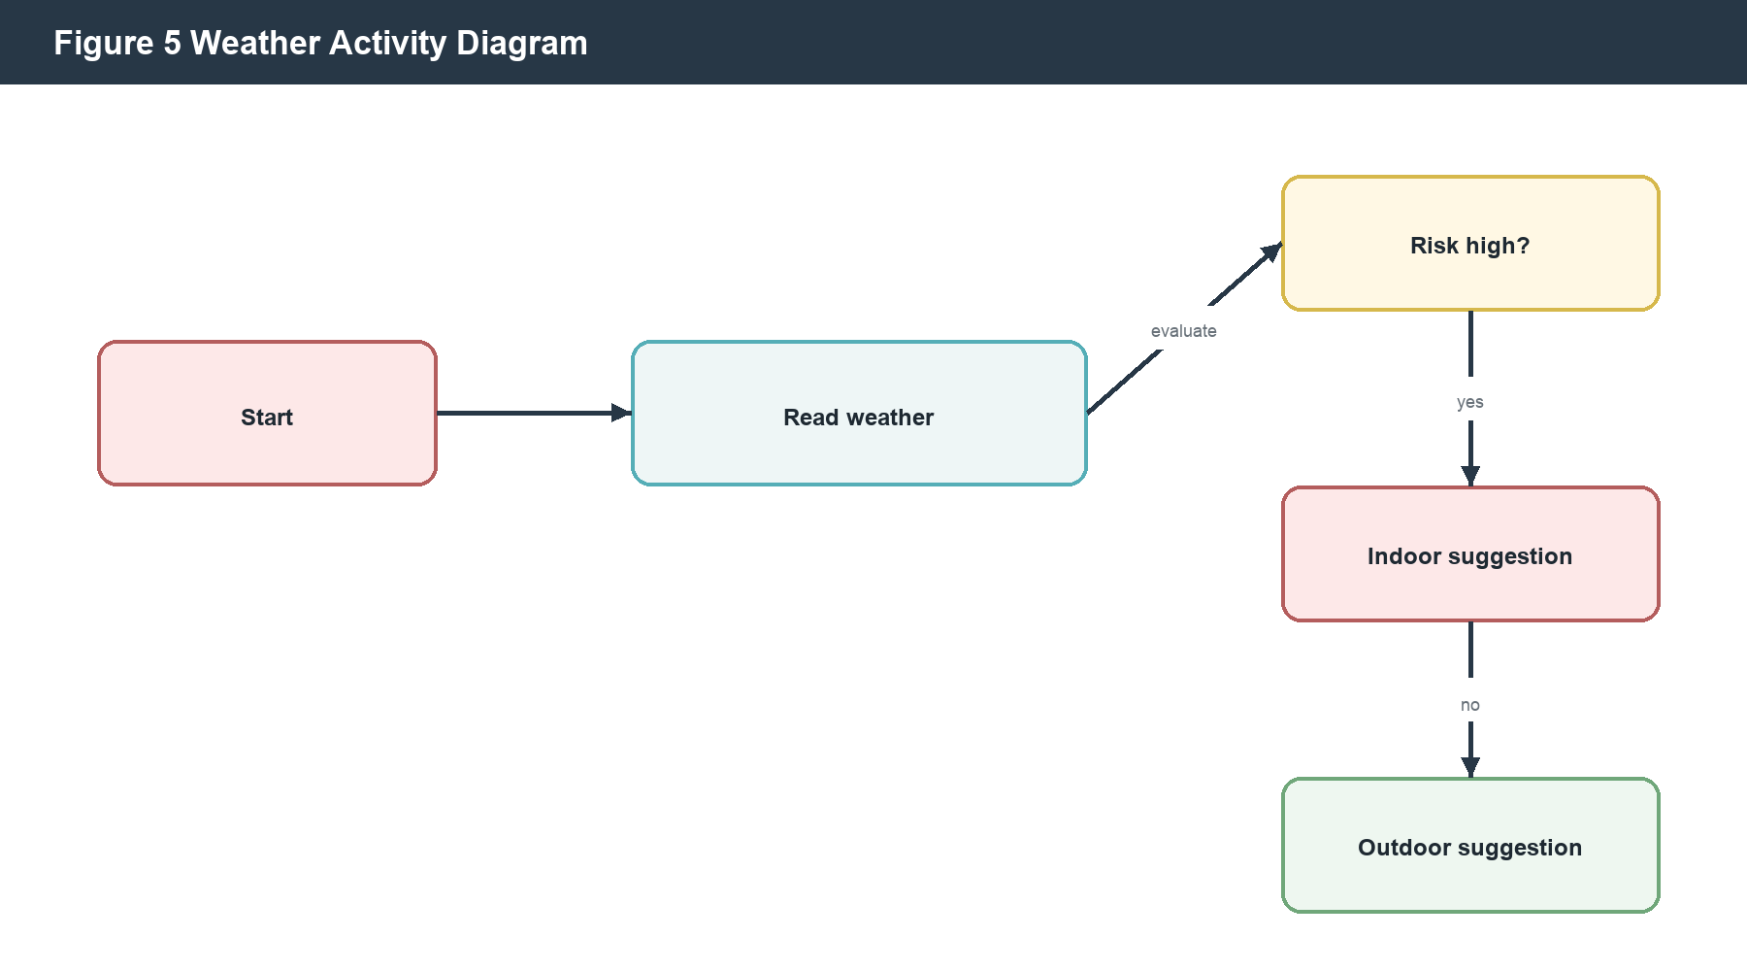
Figure 5: Activity diagram for an activity suggestion

10.2 Sequence Diagram
The sequence diagram shows search and chat interactions across the visitor, React UI, Express API and external providers.
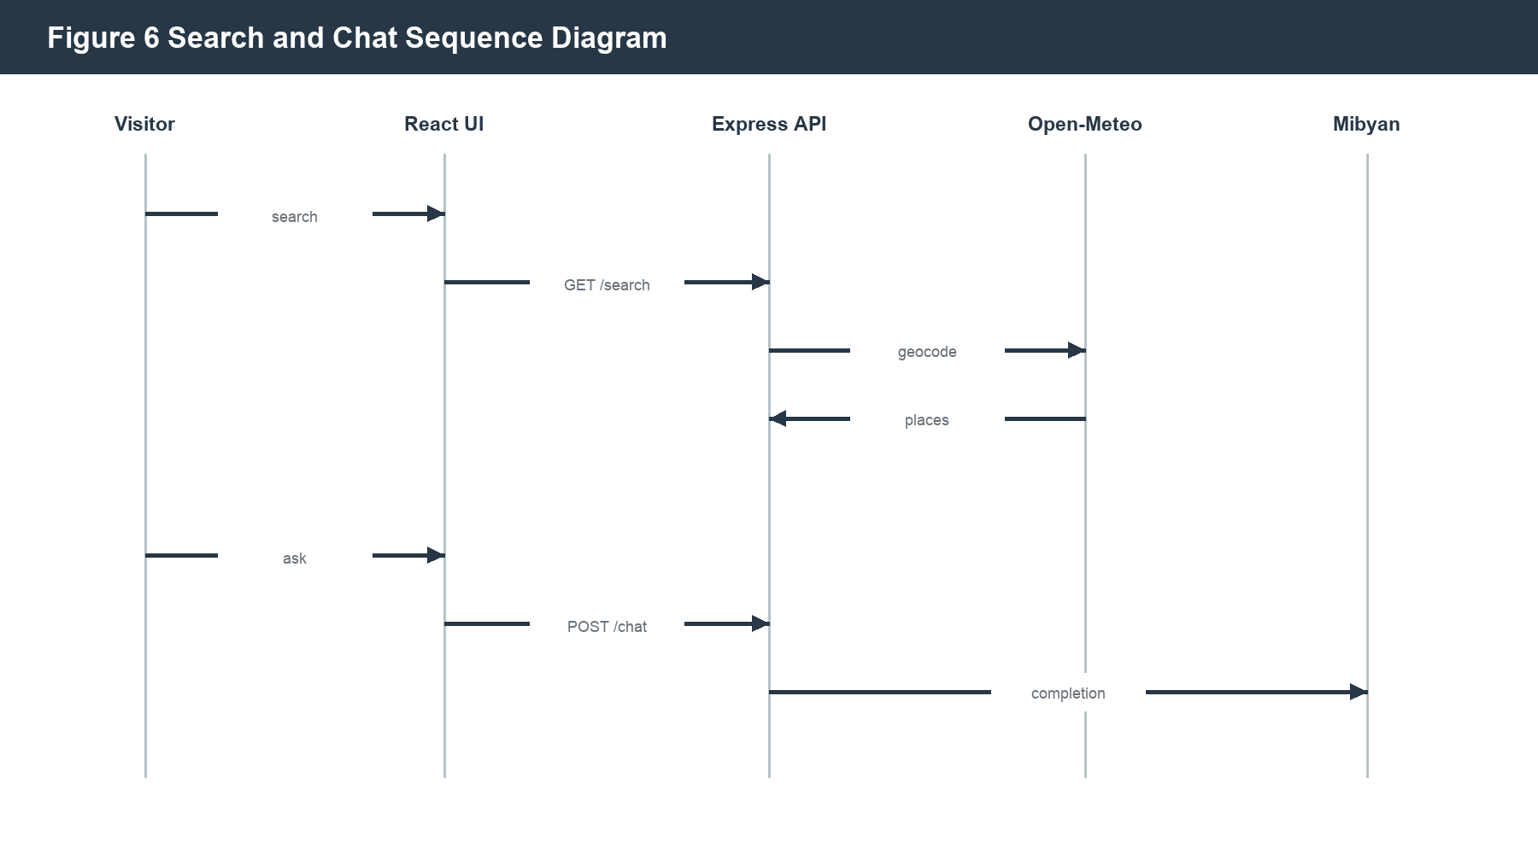
Figure 6: Search and chat sequence diagram

10.3 Component Diagram
Because the project is functional React/TypeScript rather than a class-based object model, a component diagram is more accurate than an invented class diagram.
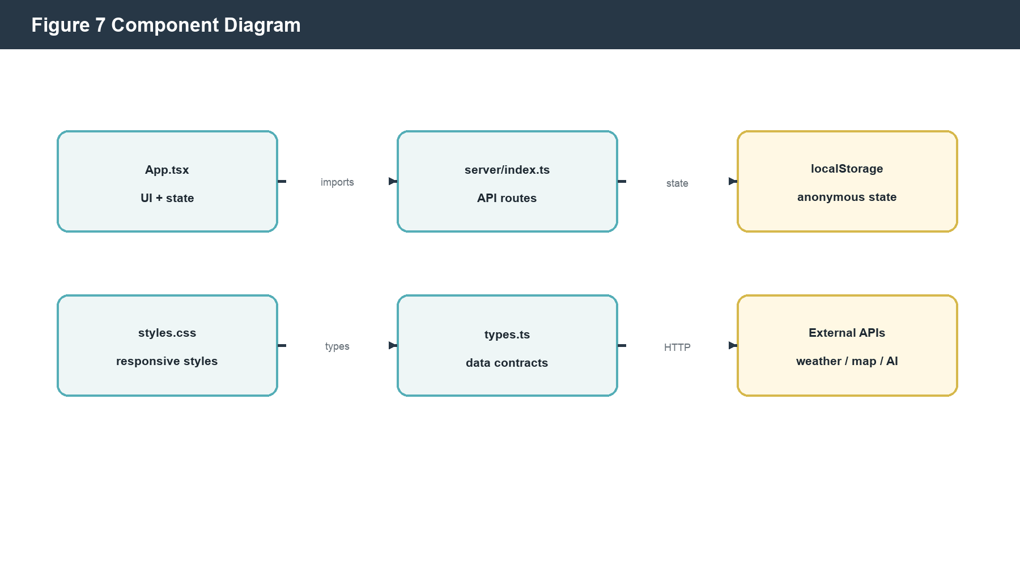
Figure 7: Component diagram of the implemented code structure

11 User Interface and UX Design
The visual language is a light, card-based dashboard inspired by the supplied Atmos Weather reference. It uses a full-width canvas, rounded paper cards, restrained grey surfaces, dark ink typography and teal accents. The top bar combines branding, theme/unit controls, city search and current-location access. The main area prioritises today’s view, a five-card viewport over a horizontally scrollable 24-hour strip, the current-weather card, activities, map and saved places.
At phone width the dashboard becomes a vertical flow. The hourly strip keeps its own horizontal scroll so the document itself does not expand. The chat becomes a bounded popup. Browser inspection at a 539px viewport showed document width equal to viewport width while the hourly strip retained a larger internal scroll width.
Accessibility measures include readable contrast, semantic buttons, Escape-to-close search, aria labels on key chat controls and a design that does not require colour alone to understand weather values. A complete WCAG and screen-reader audit was not executed.
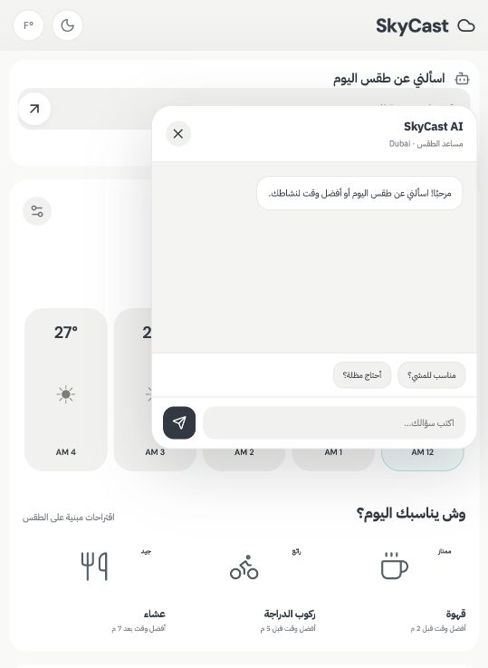
Figure 9: Actual mobile browser screenshot of the dashboard and chat popup

12 Database Design
No database was found. There are no migrations, collections, server-side user records or authentication routes. Saved places, selected place and theme are stored in browser localStorage. This is suitable for anonymous local persistence but is device-specific and cannot synchronise between devices.

12.1 Proposed Future Database
If accounts are later required, a future schema could contain User, SavedPlace, Preference and ChatSession entities with strict ownership checks. This is a proposal only and is not an implemented database.

13 Technology Stack
Technology | Purpose | Where used | Justification
React | Interactive UI | src/App.tsx | Component rendering and hooks
TypeScript | Types and checks | src, server | Catches interface mistakes early
Vite | Dev/build tooling | package scripts | Fast feedback and bundling
Node/Express | Server API | server/index.ts | Protects keys and centralises calls
Open-Meteo | Weather/geocoding | API routes | Forecast payload
Mibyan AI | Chat | /api/chat | OpenAI-compatible endpoint
Leaflet/OSM | Map | WeatherMap | Interactive marker map
Lucide React | Icons | App.tsx | Reusable SVG icons
localStorage | Local persistence | browser effects | No DB needed currently

14 Software Implementation

14.1 Structure
App.tsx contains the main composition, state and interaction handlers. styles.css contains the visual system and responsive overrides. types.ts defines Place and WeatherData. server/index.ts contains Express routes and external-provider calls. package.json provides client, server, combined development and production build scripts.
File | Responsibility
src/App.tsx | Dashboard, state, weather/search/chat interactions, Metric and WeatherMap
src/styles.css | Typography, cards, responsive layout, theme and chat
src/types.ts | Place and WeatherData contracts
server/index.ts | Health, search, weather, reverse-geocode and chat routes
.env/.env.example | Runtime configuration and key placeholders
package.json | Dependencies and scripts

14.2 State and Data
Hooks manage selected place, favourites, weather, search text, unit, theme, chat messages and typing state. Effects load weather after a place change, debounce search, load favourite temperatures, write localStorage and scroll the chat to the latest message.

14.3 API Routes
Route | Method | Purpose | Dependency
/api/health | GET | Health/config response | None
/api/search | GET | Arabic/English place search | Open-Meteo geocoding
/api/weather | GET | Current/hourly/daily forecast | Open-Meteo
/api/reverse-geocode | GET | Coordinate area name | Nominatim
/api/chat | POST | Weather assistant | Mibyan or fallback

14.4 Error Handling and Reuse
The client catches failed fetches and prevents a failed request from crashing the page. The server validates coordinates and uses a bounded chat fallback. Metric removes repeated metric markup, WeatherMap isolates map lifecycle, environment variables keep provider configuration out of browser code, and CSS variables reuse theme values. App.tsx is still relatively concentrated and should be decomposed as the feature set grows.

15 Software Construction Fundamentals

15.1 Minimizing Complexity
The system avoids accounts and a database because the current anonymous workflow does not need them. Its API surface is small, although App.tsx is now the main complexity hotspot.

15.2 Anticipating Change
Provider URLs and model names are environment-configurable. The API boundary permits upstream replacement without rewriting every UI card.

15.3 Constructing for Verification
The build performs TypeScript and Vite checks; the health endpoint exposes a simple diagnostic; browser checks cover Arabic search, phone layout, internal hourly scrolling and chat behaviour.

15.4 Reuse
React, Express, Leaflet and Lucide are reused libraries. Metric, WeatherMap, CSS variables and typed data shapes reduce repetition.

15.5 Standards in Construction
The project uses TypeScript, npm scripts, a src/server separation and environment-based secrets. Automated unit tests, linting and a formal schema are not yet present.

16 Testing Strategy
Executed checks included the production build, health/weather/reverse-geocoding requests, Arabic search, browser interaction, mobile layout measurements and provider-failure diagnosis. No automated unit suite, coverage report, load test, formal accessibility audit or penetration test was found.
ID | Req. | Test | Precondition | Expected | Actual | Status
TC-01 | FR-01 | Load dashboard | Open root | Weather cards render | Rendered in browser | Passed
TC-02 | FR-02 | Search Arabic “دبي” | Enter text | Result includes country | Returned and rendered | Passed
TC-03 | FR-04 | Use GPS | Permission | Area name appears | Permission-dependent | Partial
TC-04 | FR-05 | Hourly strip | Phone width | Only strip scrolls | Body width equals viewport | Passed
TC-05 | FR-06 | Save place | Result exists | Row remains after refresh | Implemented | Passed
TC-06 | FR-08 | Map marker | Tiles available | Marker follows selection | Implemented | Partial
TC-07 | FR-09 | Mibyan response | Valid project key | Model completion | Current key rejected | Failed prerequisite
TC-08 | FR-10 | Provider failure | Invalid/limited key | Fallback appears | Observed | Passed
TC-09 | FR-09 | Chat scroll | Several messages | Last message visible | Auto-scroll verified | Passed
TC-10 | NFR | Production build | Dependencies | Build exits cleanly | npm run build passed | Passed

16.1 Coverage and Bug Tracking
No coverage percentage is claimed. Future coverage should target route validation, search deduplication, localStorage, loading/error states, provider failures and map cleanup. A future bug record should contain ID, reproduction, expected/actual result, severity, fix and regression test.

17 Software Quality Evaluation
Dimension | Assessment | Classification
Correctness | Core weather/search flows are implemented; AI depends on key | Partially verified
Readability | Names are clear; App.tsx is dense | Partially verified
Maintainability | Server boundary and env config are useful | Partially verified
Reliability | Chat fallback prevents total failure | Verified for fallback
Usability | No login, disambiguation and mobile containment | Verified for tested view
Performance | No benchmark | Not tested
Security | Server-side key handling; no formal audit | Partially verified
Compatibility | Phone viewport checked; device matrix incomplete | Partially verified

18 Security and Privacy
Mibyan credentials are read by Express from environment variables and are not sent to the React browser. Coordinate and query inputs are validated before provider calls. CORS is permissive for local development and should be restricted for deployment. Location is used to retrieve weather and reverse geocoding; a future analytics or account layer would require clear privacy choices. No authentication or authorization exists because no accounts exist.

19 Challenges and Limitations
- No database, accounts or cross-device synchronisation.
- Weather values depend on upstream provider location, timing and model.
- The map is a base map with marker; weather raster layers and storms are not implemented.
- Mibyan adapter exists, but the current project key returned HTTP 401 during verification.
- Fallback chat is bounded and is not equivalent to model reasoning or web search.
- App.tsx needs feature extraction as scope grows.
- No automated tests, coverage, load, accessibility or security audit was found.

20 Future Improvements
Improvement | Problem | Benefit | Complexity | Priority
Validate/rotate Mibyan key | 401 prevents live completions | Real AI answers | Low | High
Extract service modules | Dense App.tsx | Easier tests/providers | Medium | High
Automated tests | Manual verification only | Regression evidence | Medium | High
Weather map layers | Base marker map | Storm/rain context | High | Medium
Comparison view | Limited saved-row comparison | Better planning | Medium | Medium
Account sync | Device-only storage | Cross-device favourites | High | Low
Rate limiting/schema validation | Public routes | Safer deployment | Medium | High
Accessibility audit | Partial checks | Better inclusive access | Medium | Medium

21 Conclusion
Al-Tarqi SkyCast demonstrates a complete small-scale web construction project with a clear visitor workflow: enter the dashboard, identify a place, read current and hourly weather, save places, inspect a map and ask for an interpretation. The solution is grounded in React/TypeScript, Node/Express, Open-Meteo, Leaflet/OpenStreetMap, localStorage and an OpenAI-compatible Mibyan adapter.
The project demonstrates practical Software Construction through API boundaries, environment configuration, reusable UI functions, responsive containment, error handling and iterative verification. The report also preserves an important engineering distinction: the Mibyan integration is implemented according to its documented contract, but the current key failed authentication, so live model quality is not claimed. The fallback provides continuity but remains limited.

22 References
Mibyan AI. (n.d.). API overview. https://docs.mibyanai.com/api-reference/introduction
Mibyan AI. (n.d.). API quickstart. https://docs.mibyanai.com/api-reference/quickstart
Open-Meteo. (n.d.). Weather API documentation. https://open-meteo.com/en/docs
Open-Meteo. (n.d.). Geocoding API documentation. https://open-meteo.com/en/docs/geocoding-api
Leaflet. (n.d.). Leaflet reference. https://leafletjs.com/reference.html
OpenStreetMap Foundation. (n.d.). Copyright and attribution. https://www.openstreetmap.org/copyright
React. (n.d.). React documentation. https://react.dev/
TypeScript. (n.d.). TypeScript handbook. https://www.typescriptlang.org/docs/handbook/intro.html
Vite. (n.d.). Vite guide. https://vite.dev/guide/
Express. (n.d.). Express documentation. https://expressjs.com/
MDN Web Docs. (n.d.). Window localStorage. https://developer.mozilla.org/en-US/docs/Web/API/Window/localStorage
MDN Web Docs. (n.d.). Geolocation API. https://developer.mozilla.org/en-US/docs/Web/API/Geolocation_API

Appendix A Technical Details
Item | Detail
Weather | GET /api/weather?latitude=...&longitude=...
Search | GET /api/search?q=...
Chat | POST /api/chat with question, weather and location JSON
Mibyan config | MIBYAN_API_KEY, MIBYAN_BASE_URL, MIBYAN_MODEL
Storage | skycast:place, skycast:favorites, skycast:theme
Database | None found in current implementation

Appendix B Evidence Notes
This report was generated from the project source files, package configuration, executed build/API checks, browser inspection at a phone-sized viewport and the captured mobile screenshot. Student and course metadata remain editable placeholders because they were not supplied.

Appendix C Diagram Index
01_system_architecture.png
02_use_case.png
03_customer_journey.png
04_user_flow.png
05_activity.png
06_sequence.png
07_component.png
08_development_cycle.png

